SAMPLE SIZE: numbers between 0 and 9999999

DATA SIZE 100

time take by iterative bubble sort = 0.000134

time take by recursive bubble sort = 0.000084

time take by mergesort = 0.000019

time take by qsort = 0.000012

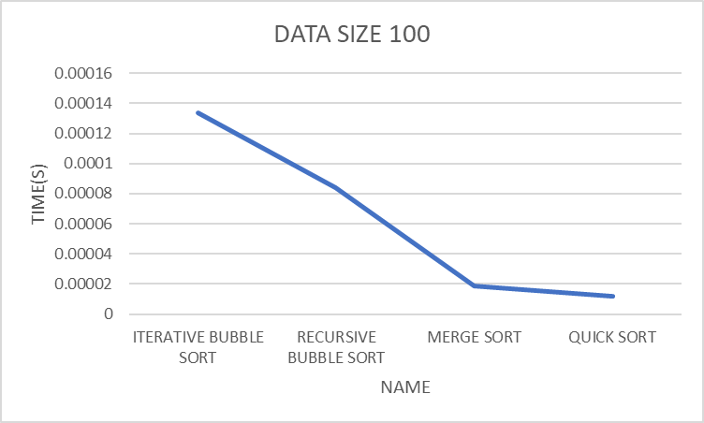

DATA SIZE 1000

time take by iterative bubble sort = 0.009220

time take by recursive bubble sort = 0.009038

time take by mergesort = 0.000548

time take by qsort = 0.000392

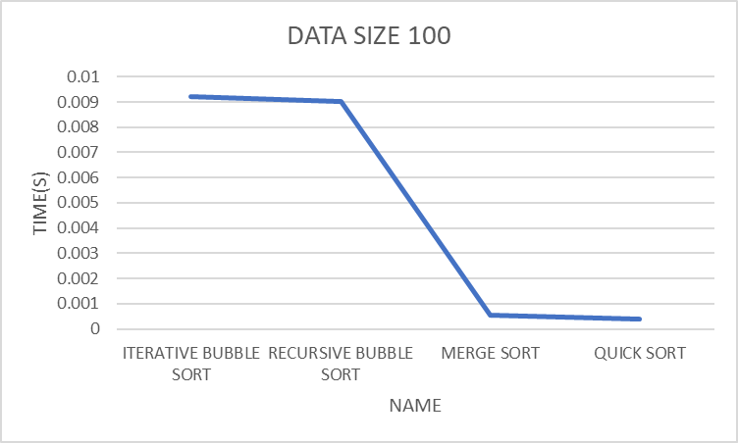

DATA SIZE 5000

time take by iterative bubble sort = 0.075750

time take by recursive bubble sort = 0.059739

time take by mergesort = 0.000725

time take by qsort = 0.000522

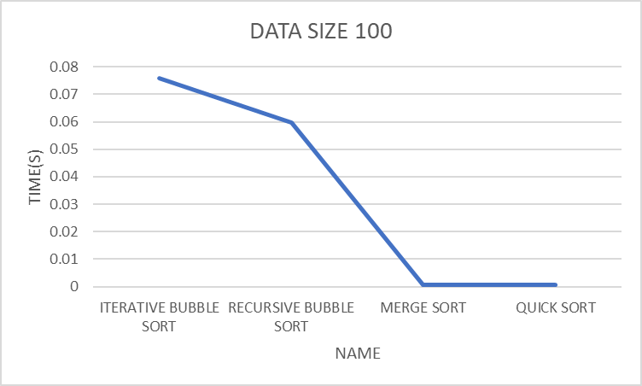

DATA SIZE 10000

time take by iterative bubble sort = 0.076668

time take by recursive bubble sort = 0.060478

time take by mergesort = 0.000724

time take by qsort = 0.000519

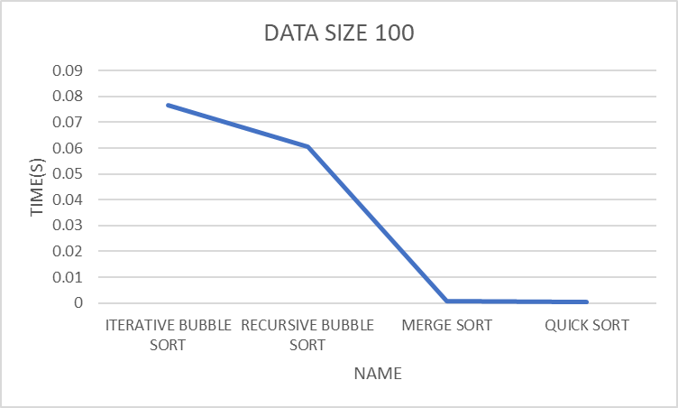

DATA SIZE 25000

time take by iterative bubble sort = 1.986529

time take by recursive bubble sort = 1.884230

time take by mergesort = 0.004107

time take by qsort = 0.002988

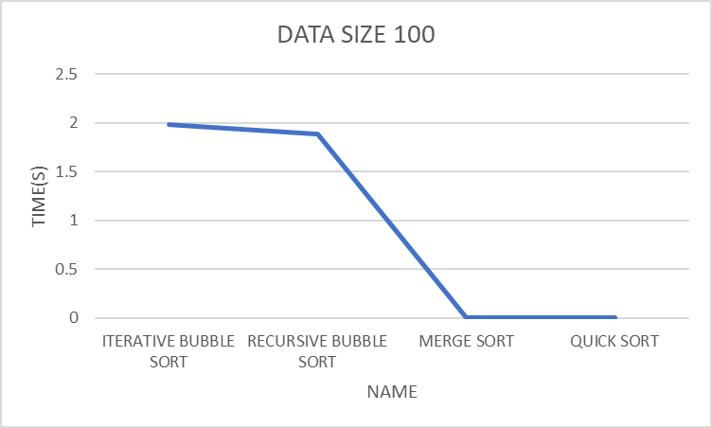

DATA SIZE 50000

time take by iterative bubble sort = 8.203230

time take by recursive bubble sort = 7.920014

time take by mergesort = 0.008674

time take by qsort = 0.006552

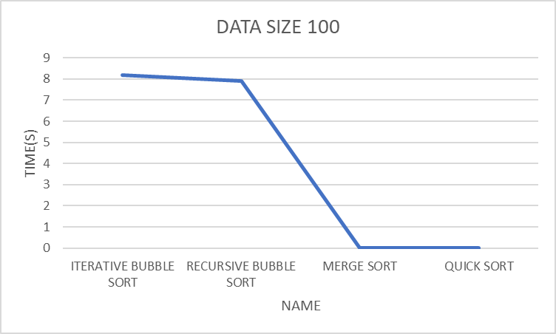

DATA SIZE 75000

time take by iterative bubble sort = 19.035703

time take by recursive bubble sort = 18.217556

time take by mergesort = 0.013514

time take by qsort = 0.009989

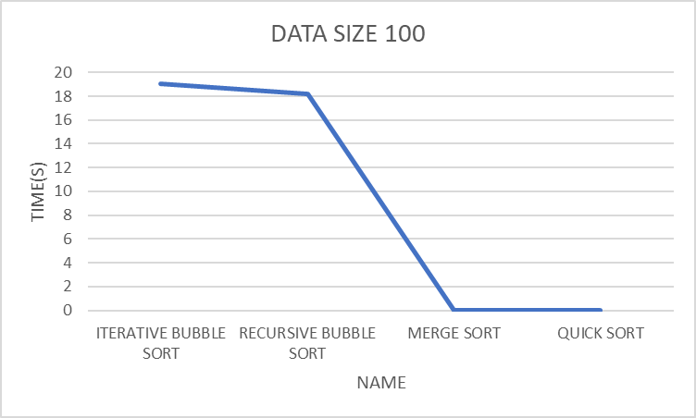

DATA SIZE 100000

time take by iterative bubble sort = 18.831402

time take by recursive bubble sort = 18.137690

time take by mergesort = 0.013531

time take by qsort = 0.009987

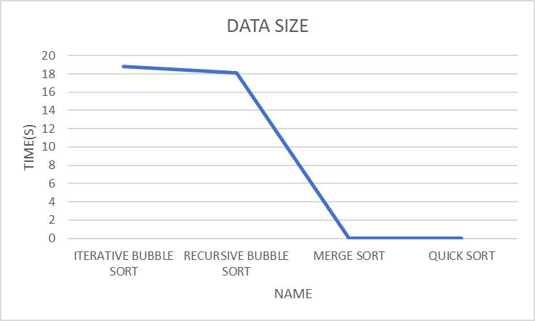Top of Form